**DEPARTMENT – Physics**

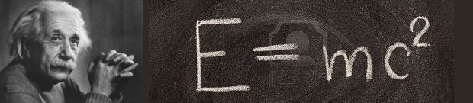

**FACULTY members**

**HEAD OF THE DEPARTMENT**

**Dr. S. Kumararaman**, M. Sc., M. Phil., Ph. D., PGDCA

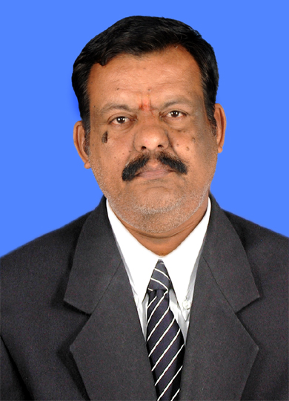hoto

E-mail : kumararaman2001@yahoo.com

Cell : 9443602725

[View Profile]

**ASSOCIATE PROFESSORS**

**Prof. K. Nagarajan**, M. Sc., M. Phil.,

Photo

E-mail : venkatathan@gmail.com

Cell : 9443879116

[View Profile]

**Dr. K. Gnanasekaran**, M. Sc., B. Ed., M. Phil., Ph. D,

Photo

E-mail : kggnanam@gmail.com

Cell : 9443139336

[View Profile]

**Dr. A. Venkatesan**, M. Sc., M. Phil., Ph. D,

Photo

E-mail : av.phys@gmail.com

Cell : 9443008804

[View Profile]

Photo

**Dr. A. Rajendran**, M. Sc., PGDMCH., Ph. D,

E-mail : neelrajnmc@gmail.com

Cell : 9943320598

[View Profile]

**ASSISTANT PROFESSORS**

**Dr. P. Palaniyandi**, M. Sc., Ph. D,

Photo

E-mail : pazhani99@gmail.com

Cell : 9443688637

[View Profile]

**Mrs. R. Sangeetha**, M. Sc., M. Phil.,

Photo

E-mail : sangeethaashok78@gmai.com

Cell : 7708258847

[View Profile]

**Mr. P.R. Venkatesh**, M. Sc., M.Phil., PGDCA,

Photo

E-mail : venkatesh.sprv@gmai.com

Cell : 9486063559

[View Profile]

**Dr. V.Pandiyan**, M.Sc., Ph.D,

Photo

E-mail : pandiyanphy@gmail.com

Cell : 9159121779

[View Profile]

**Dr. M. Pandiaraman**, M.Sc., Ph.D,

Photo

E-mail : pandiaraman@gmail.com

Cell : 9942599246

[View Profile]

**Dr. K. Srinivasan**, M.Sc., Ph.D,

Photo

E-mail : ksrini1@gmail.com

Cell : 9994192433

[View Profile]

**SELF FINANCED STAFF**

**ASSISTANT PROFESSORS**